الكتاب المستخرج: Screenshot from 2026-06-30 02-20-37.png
--- الصفحة [1] ---
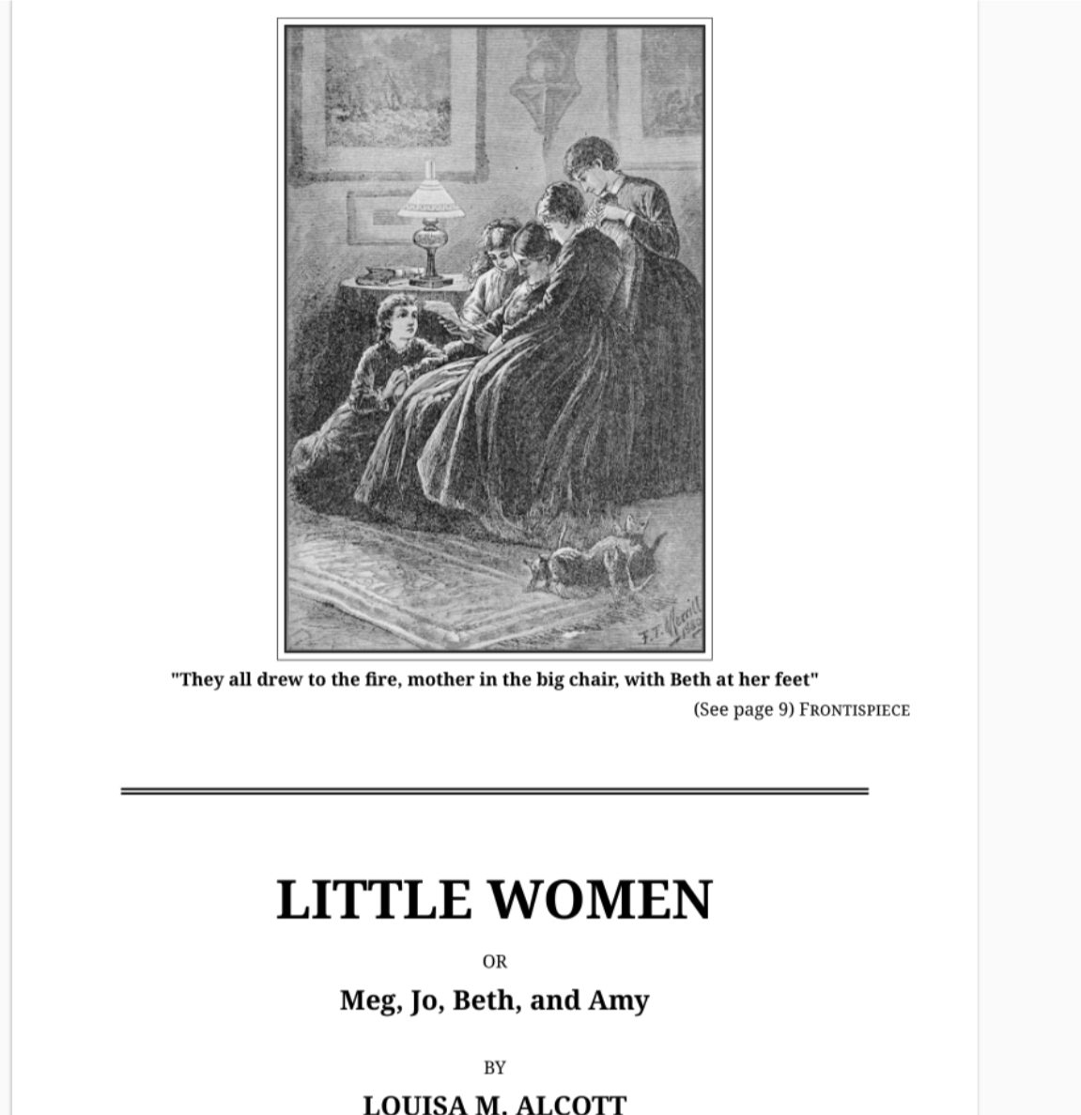
صورة تلقائية #1

£ WEiee § oAl § |
Ely S OV
R W
o N J
..M!’ Py i
=g ‘
£
[
'I/ 7 ; // ,[ J/
Y/
5 j AR
S CAUIRRTS
T DN DAIE et e e A
"They all drew to the fire, mother in the big chair, with Beth at her feet"
(See page 9) FRONTISPIECE
OR
Meg, Jo, Beth, and Amy
BY
LOUISA M. ALCOTT

